

Lab Experiment – 12
Tic-Tac-Toe Game

Aim
To implement a Tic-Tac-Toe game using Python.

Objective
To develop a two-player Tic-Tac-Toe game where players take turns placing X and O on a 3×3 board.

Algorithm
- Start the game.
- Initialize a 3×3 board with empty spaces.
- Display the board.
- Ask the current player to select a position.
- Place the player's symbol (X or O) in the selected position.
- Check whether the player has won.
- If a player wins, display the winner and stop.
- Check whether the board is full.
- If the board is full, declare the game as a draw.
- Otherwise, switch to the other player.
- Repeat the process until the game ends.

FlowChart
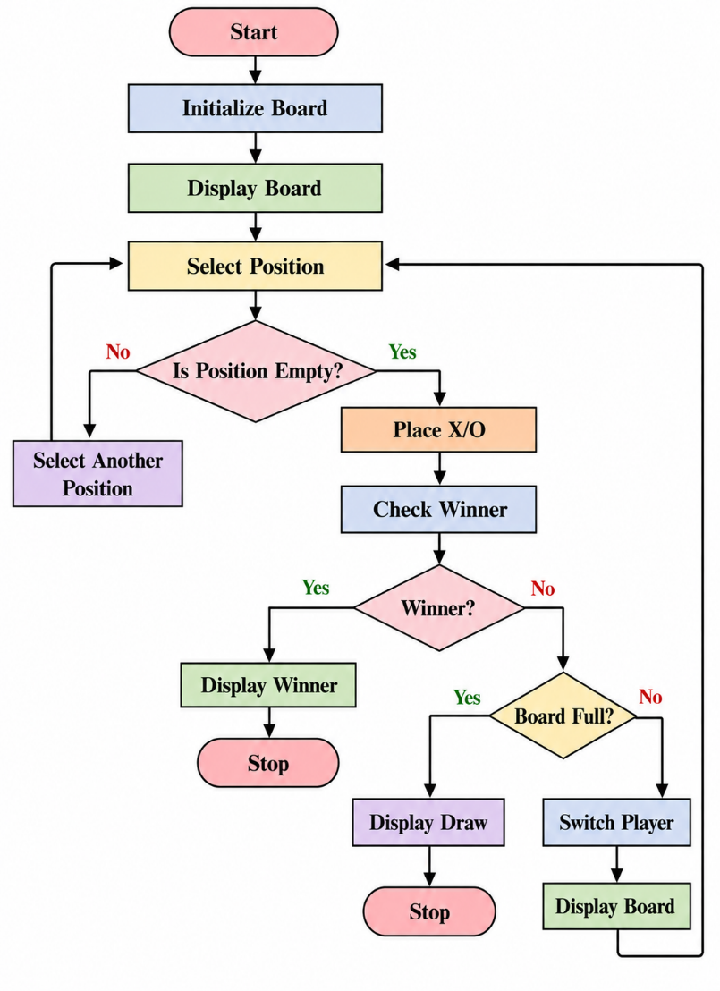
Code
def print_board(board):
print("\n")
print(" | ".join(board[0:3]))
print("--+---+--")
print(" | ".join(board[3:6]))
print("--+---+--")
print(" | ".join(board[6:9]))
print()

def check_winner(board, player):
winning_positions = [
(0, 1, 2),
(3, 4, 5),
(6, 7, 8),
(0, 3, 6),
(1, 4, 7),
(2, 5, 8),
(0, 4, 8),
(2, 4, 6)
]

for a, b, c in winning_positions:
if board[a] == board[b] == board[c] == player:
return True

return False

board = [" "] * 9
player = "X"

for turn in range(9):
print_board(board)

position = int(input(
f"Player {player}, enter position (1-9): "
)) - 1

if position < 0 or position > 8 or board[position] != " ":
print("Invalid position. Try again.")
continue

board[position] = player

if check_winner(board, player):
print_board(board)
print("Player", player, "wins!")
break

player = "O" if player == "X" else "X"

else:
print_board(board)
print("Game Draw!")

Output
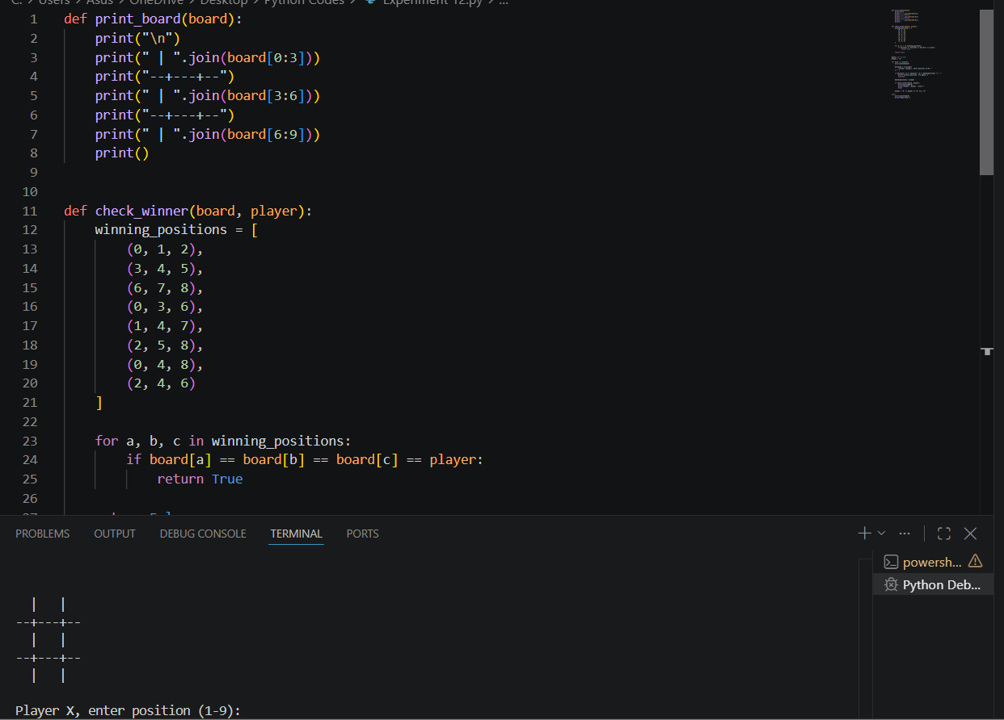

Result
The Tic-Tac-Toe game was successfully implemented in Python.

Conclusion
The program successfully implements a two-player Tic-Tac-Toe game by managing player turns, validating positions, checking winning combinations, and identifying a draw when the board becomes full.

